Greater Minnesota

Transportation Alternatives Solicitation
2023/24 Solicitation Guidebook
Funding in year 2028

Table of Contents
Table of Contents 2
Overview 3
Related Documents 3
2023/24 Solicitation Timeline 3
Transportation Alternatives Solicitation Information 4
Federal Program Requirements 4
Qualifying Activities 4
Non-Qualifying Activities 5
Project Sponsors and Applicants 6
Sponsors 6
Applicants 6
Local Match and Cost Sharing Requirements 7
Timeline Guidance for Project Development to Construction 8
RDO & MPO Contact Information 9
Regional Development Organization Contact Information 10
Metropolitan Planning Organization Contact Information 11
ATP Contact Information 12
Area Transportation Partnership Contact Information 13
Other Key Contacts 14
Safe Routes to School, Scenic Byway & Recreational Trails Program Coordinator Contact Information 14
Statewide Transportation Alternatives Contact Information 14
Note: The solicitation for Transportation Alternatives funding for the seven-county Twin Cities metropolitan area (Anoka, Carver, Dakota, Hennepin, Ramsey, Scott and Washington counties) is conducted by the Metropolitan Council and the Transportation Advisory Board. For more information about the metro area solicitation, visit the Met Council website.

Overview
For the 2023/24 application cycle, MnDOT is conducting a solicitation for Transportation Alternatives (TA) projects. This document explains the overall solicitation process and the eligibility requirements for TA funding.

Related Documents
- TA Solicitation Letter of Intent Worksheet – includes information on the letter of intent review process and a worksheet to assist with completing the online letter of intent form.
- TA Solicitation Full Application – the full application form for the TA solicitation. Full application documents are available from each ATP directly.

2023/24 Solicitation Timeline
- Monday October 2, 2023 – Announce TA solicitation. Open letter of intent period.
- Friday, November 3rd, 2023 – Deadline for applicants to submit letters of intent.
- Monday, November 20th, 2023 – Deadline for RDO/MPO/district review of letters of intent. Recommendation to proceed forward with full application given to applicants.
- Friday, November 24th, 2023 – Official start of full application period.
- Friday, January 12th, 2024– Deadline for applicants to submit full applications.
- Friday, April 12th, 2024 – Deadline for ATPs to select TA projects.

Transportation Alternatives Solicitation Information

Federal Program Requirements
Following is a partial listing of the regulations that apply to any project receiving federal transportation funds. These requirements must be taken into consideration for budget development, project development and project implementation stages.
Davis-Bacon and Copeland Acts: Payment of pre-determined wage is applicable to all federal-aid construction contracts exceeding $2,000 and to all related subcontracts.
ADA Requirements: All TA projects must comply with the federal and state accessibility mandates. For additional information contact State Aid for Local Transportation.
Anti-Discrimination Laws: Each sponsoring participant must comply with applicable federal and state Anti-discrimination laws and be able to demonstrate compliance.
Project Supervision: All projects must be under the direct supervision of a Minnesota Licensed Professional Engineer.
Additional Requirements and Specifications: Successful applicants will be provided with additional information as needed by Minnesota Department of Transportation (MnDOT).

Qualifying Activities
As identified in federal law, TA funds may be obligated for projects or activities described in 23 U.S.C. 101(a)(29) or 213, as such provisions were in effect on the day before the date of enactment of the FAST Act.
Former 23 U.S.C. 213(b)(1):
- TA as defined in section 101 [former 23 U.S.C. 101(a)(29)]:
The term “Transportation Alternatives” means any of the following activities when carried out as part of any program or project authorized or funded under this title, or as an independent program or project related to surface transportation:
  - Construction, planning, and design of on-road and off-road trail facilities for pedestrians, bicyclists, and other non-motorized forms of transportation, including sidewalks, bicycle infrastructure, pedestrian and bicycle signals, traffic calming techniques, lighting and other safety-related infrastructure, and transportation projects to achieve compliance with the Americans with Disabilities Act of 1990 (42 U.S.C. 12101 et seq.).
  - Construction, planning, and design of infrastructure-related projects and systems that will provide safe routes for non-drivers, including children, older adults, and individuals with disabilities to access daily needs.
  - Conversion and use of abandoned railroad corridors for trails for pedestrians, bicyclists, or other non-motorized transportation users.
  - Construction of turnouts, overlooks, and viewing areas.
  - Community improvement activities, which include but are not limited to:
    - inventory, control, or removal of outdoor advertising;
    - historic preservation and rehabilitation of historic transportation facilities;
    - vegetation management practices in transportation rights-of-way to improve roadway safety, prevent against invasive species, and provide erosion control; and
    - archaeological activities relating to impacts from implementation of a transportation project eligible under title 23.
  - Any environmental mitigation activity, including pollution prevention and pollution abatement activities and mitigation to:
    - address stormwater management, control, and water pollution prevention or abatement related to highway construction or due to highway runoff, including activities described in sections 23 U.S.C. 133(b)(3) [as amended under the FAST Act], 328(a), and 329 of title 23; or
    - reduce vehicle-caused wildlife mortality or to restore and maintain connectivity among terrestrial or aquatic habitats (Former 23 U.S.C. 213(b)(2)-(4)).
- The recreational trails program under 23 U.S.C. 206 of title 23.
- The scenic byways program under U.S.C. 162 of title 23.
- The safe routes to school program eligible projects and activities listed at section 1404(f) of the SAFETEA-LU:
  - Infrastructure-related projects.
  - Noninfrastructure-related activities.
  - SRTS coordinator. SAFETEA-LU section 1404(f)(2)(A) lists “managers of safe routes to school programs” as eligible under the noninfrastructure projects.
- Planning, designing, or constructing boulevards and other roadways largely in the right-of-way of former Interstate System routes or other divided highways.
  - See Boulevards from Divided Highways for examples.
There are no location restrictions for TA set-aside infrastructure projects; they are not required to be located along highways.
For SRTS noninfrastructure projects, traffic education and enforcement activities must take place within approximately two miles of a primary or middle school (kindergarten through 8th grade).

Non-Qualifying Activities
As identified in federal law, TA funds cannot be used for the following activities because there is no authorization under the Federal-aid Highway Program:
- State or metropolitan planning organization administrative purposes. Exceptions:
  - See FHWA’s Memo Allocating Indirect Costs to Projects, dated September 4, 2015.
  - RTP administrative costs of the State for RTP set-aside funds.
- Promotional activities, except as permitted under the SRTS (2 CFR 200.421(e)(3)).
- Routine maintenance and operations, except trail maintenance as permitted under the RTP.
- General recreation and park facilities, playground equipment, sports fields, campgrounds, picnic areas and pavilions, etc.
MnDOT has elected that the following activities are also considered ineligible for TA funding, even if not prohibited federally.
- Engineering activities
- Purchase of right-of-way

Project Sponsors and Applicants

Sponsors
Federal funds for TA projects are passed through MnDOT to recipients that are adequately staffed and equipped to undertake and satisfactorily complete the requirements associated with federally-funded work. MnDOT determined that state aid cities (i.e. cities with population of over 5,000 persons) and counties are qualified recipients for federal funds. The TA solicitation requires their participation as a sponsor and/or applicant. If an eligible applicant is not a state aid city or county, then the applicant will need a state aid city or county to be a sponsor on their project. For a full description of state aid sponsor requirements please review the state aid manual.

Applicants
Project applicants must be an entity eligible to receive federal TA funding. Eligible applicants are:
- a local government: Local government entities include any unit of local government below a State government agency, except for an MPO. Examples include city, town, township, or county agencies.
- a regional transportation authority: Regional transportation authorities are considered the same as the Regional Transportation Planning Organizations defined in the statewide planning section (23 U.S.C. 135(m)).
- a transit agency: Transit agencies include any agency responsible for public transportation that is eligible for funds as determined by the Federal Transit Administration.
- a natural resource or public land agency: Natural resource or public land agencies include any Federal, Tribal, State, or local agency responsible for natural resources or public land administration. Examples include:
  - State or local park or forest agencies;
  - State or local fish and game or wildlife agencies;
  - Department of the Interior Land Management Agencies; and
  - U.S. Forest Service.
- a school district, local education agency, or school: School districts, local education agencies, or schools may include any public or nonprofit private school. Projects should benefit the general public and not only a private entity.
- a tribal government.
- a nonprofit entity responsible for the administration of local transportation safety programs: Examples include a nonprofit entity responsible for:
  - a local program implementing construction, planning, and design of infrastructure-related projects and systems that will provide safe routes for non-drivers, including children, older adults, and individuals with disabilities to access daily needs; and
  - a safe routes to school program.
- any other local or regional governmental entity with responsibility for, or oversight of, transportation or recreational trails (other than an MPO or a State agency) that the State determines to be eligible, consistent with the goals of this subsection.
State DOTs and MPOs are not eligible entities as defined under 23 U.S.C. 133(h)(4)(B) and therefore are not eligible project sponsors for TA funds. However, State DOTs and MPOs may partner with an eligible entity project sponsor to carry out a project.
Nonprofit organizations are not eligible as direct grant subrecipients for TA funds unless they qualify through one of the eligible entity categories (e.g., where a nonprofit organization is a designated transit agency, school, or an entity responsible for the administration of local transportation safety programs). Nonprofit entities are eligible to partner with any eligible entity on an eligible project, if State or local requirements permit.
Tribal governments need to be federally recognized to be eligible entities for TA funding. If a tribal government is not a federally recognized tribe, the tribe does not possess certain inherent rights of self-government and are not entitled to receive federal benefits, services and protections.
The Recreational Trails Program set-aside funds retain the RTP eligible project sponsor provisions under 23 U.S.C. 206 (23 U.S.C. 133(h)(5)(C)).

Local Match and Cost Sharing Requirements
For all projects, including SRTS projects, funded with TA funds, the federal share is the same as for the general federal-aid highway program: 80 percent Federal and 20 percent State or local match subject to the sliding scale adjustment. (23 U.S.C. 120)
As provided in 49 CFR 18.24 "Matching or cost sharing," the following requirements are emphasized:
- 18.24(b) Qualifications and exceptions-(1) Costs borne by other Federal grant agreements. Except as provided by Federal statute, a cost sharing or matching requirement may not be met by costs borne by another Federal grant. This prohibition does not apply to income earned by a grantee or subgrantee from a contract awarded under another Federal grant.
- (3) Cost or contributions counted towards other Federal costs-sharing requirements. Neither costs nor the values of third party in-kind contributions may count towards satisfying a cost sharing or matching requirement of a grant agreement if they have been or will be counted towards satisfying a cost sharing or matching requirement of another Federal grant agreement, a Federal procurement contract, or any other award of Federal funds.

Timeline Guidance for Project Development to Construction
Time from funding award | Activity and duration
7-13 months | Eligible agency completes planning and preliminary work to describe and estimate cost of project. (26-52 weeks but public input and collaboration with land owners may take longer)
13-20 months | Project is selected in four-year State Transportation Improvement Program. (26 weeks)
20-33 months | Eligible agency completes preliminary engineering to assess social, environmental and economic impacts and to apply design criteria. (26-52 weeks)
20-33 months | Preliminary discussions and review scoping as to appropriate document. (2 weeks)
21-36 months | Eligible agency prepares environmental document. (4-13 weeks)
23-38 months | Eligible agency submits environmental documentation to District State Aid Engineer with original signatures. (6-8 weeks)
24-40 months | District State Aid Engineer reviews the documents. Are document components appropriate / correct? If no, eligible agency is contacted to resolve. Eligible agency corrects and resubmits. (Add 6-8 weeks if second draft is needed)
26-43 months | District State Aid Engineer reviews; comments and/or approves. (8-10 weeks)
26-43 months | State Aid for Local Transportation notifies District State Aid Engineer and eligible agency of environmental clearance approval and to proceed with right of way, detailed plans and necessary documentation for federal authorization. (1-2 weeks)
32-50 months | Eligible agency completes and submits plans, right of way certification and required documentation to the District State Aid Engineer. (13-26 weeks)
35-52 months | Plan review by District State Aid Engineer and State Aid for Local Transportation. (10 weeks)
36-54 months | Federal authorization to let project. (5 weeks)
36-54 months | Bid opening and certification of Disadvantaged Business Enterprises. (2 weeks)
37-55 months | Contractor secures bond and signs contract. (2 weeks)
38-55 months | Contract approval and initiation of construction. (3 weeks)

RDO & MPO Contact Information
The Metropolitan Planning Organizations (MPO) and Regional Development Organizations (RDO) are key partners in the TA solicitation process being responsible for reviewing projects to determine success in the TA program. Any local community applicant who has questions about the application process and is interested in submitting a proposal are encouraged to connect with an RDO or MPO. Contact information may be found on the following pages where project specific questions, eligibility requirements and scoring criteria may be directed.
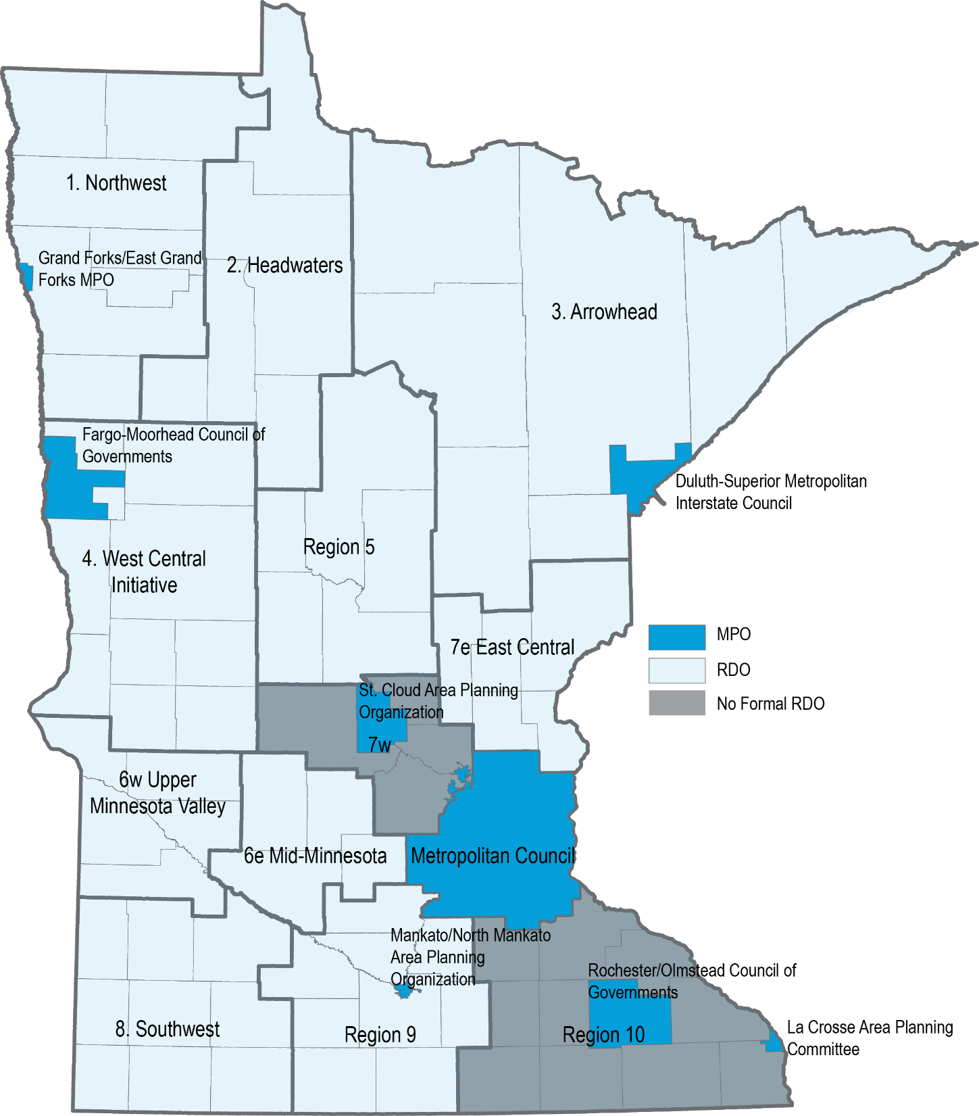

Regional Development Organization Contact Information
Region | Organization name | Counties served | Address & phone | Website
1 | Northwest Regional Development Commission | Kittson, Marshall, Norman, Pennington, Polk, Red Lake, Roseau | 109 S Minnesota St Warren, MN 56762  218-745-9107 | www.nwrdc.org
2 | Headwaters Regional Development Commission | Beltrami, Clearwater, Hubbard, Lake of the Woods, Mahnomen | 403 4th St NW  PO Box 906  Bemidji, MN 56601  218-444-4732 | www.hrdc.org
3 | Arrowhead Regional Development Commission | Aitkin, Carlton, Cook, Itasca, Koochiching, Lake, St. Louis | 221 West 1st St  Duluth, MN 55802  218-722-5545 | www.ardc.org
4 | West Central Initiative | Becker, Clay, Douglas, Grant, Otter Tail, Pope, Stevens, Traverse, Wilkin | 1000 Western Ave  PO Box 318  Fergus Falls, MN 56538  218-739-2239 | www.wcif.org
5 | Region 5 Development Commission | Cass, Crow Wing, Morrison, Todd, Wadena | 200 1st Street NE  Suite 2  Staples, MN 56479  218-894-3233 | www.regionfive.org
6e | Mid-Minnesota Development Commission | Kandiyohi, McLeod, Meeker, Renville | 333 SW 6th St  Suite 2  Willmar, MN 56201  320-235-8504 | www.mmrdc.org
6w | Upper Minnesota Valley Regional Development Commission | Big Stone, Chippewa, Lac qui Parle, Swift, Yellow Medicine | 323 W Schlieman Ave  Appleton, MN 56208  320-289-1981 | www.umvrdc.org
7e | East Central Regional Development Commission | Chisago, Isanti, Kanabec, Mille Lacs, Pine | 100 S Park St  Mora, MN 55051  320-679-4065 | http://www.ecrdc.org/
7W | Administered by MnDOT District 3 | Benton, Sherburne, Stearns and Wright | 7694 Industrial Park Road  Baxter, MN 56425  218-828-5700 | www.dot.state.mn.us/d3/atp
8 | Southwest Regional Development Commission | Cottonwood, Jackson, Lincoln, Lyon, Murray, Nobles, Pipestone, Redwood, Rock | 2401 Broadway Ave  Suite 1  Slayton, MN 56172  507-836-8547 | www.swrdc.org
9 | Region 9 Development Commission | Blue Earth, Brown, Faribault, Le Sueur, Martin, Nicollet, Sibley, Waseca, Watonwan | 3 Civic Center Plaza Suite 310 Mankato, MN 56001  507-387-5643 | www.rndc.org
10 | Administered by MnDOT District 6 | Rice, Goodhue, Wabasha, Steele, Dodge, Olmsted, Winona, Freeborn, Mower, Fillmore, Houston | 2900 48th Street NW  Rochester, MN 55901  507-286-7500 | www.dot.state.mn.us/d6/atp

Metropolitan Planning Organization Contact Information
Organization name | Address & phone | Website
Rochester-Olmstead Council of Governments | 2122 Campus Drive SE  Suite 100  Rochester, MN 55904  507-328-7100 | www.co.olmsted.mn.us
Mankato-North Mankato Area Planning Organization | 10 Civic Center Plaza  Mankato, MN 56001  507-387-8613 | www.mnmapo.org
St. Cloud Area Planning Organization | 1040 County Road 4  St. Cloud, MN 56303  320-252-7568 | www.stcloudapo.org
Fargo-Moorhead Metropolitan Council of Governments | 1 2nd Street N  Suite 232  Fargo, ND 58102  701-232-3242 | www.fmmetrocog.org
Duluth-Superior Metropolitan Interstate Council | 221 W 1st Street  Duluth MN  218-529-7509 | www.dsmic.org
La Crosse Area Planning Committee | 212 6th Street N  Room 1200  La Crosse, WI 54601  608-785-5977 | www.lapc.org
Grand Forks-East Grand Forks Metropolitan Planning Organization | 255 N 4th Street  Grand Forks, ND 58206  701-746-2660 | www.theforksmpo.org
Twin Cities Metropolitan Council | 390 Robert Street N  St. Paul, MN 55101  651-602-1000 | www.metrocouncil.org

ATP Contact Information
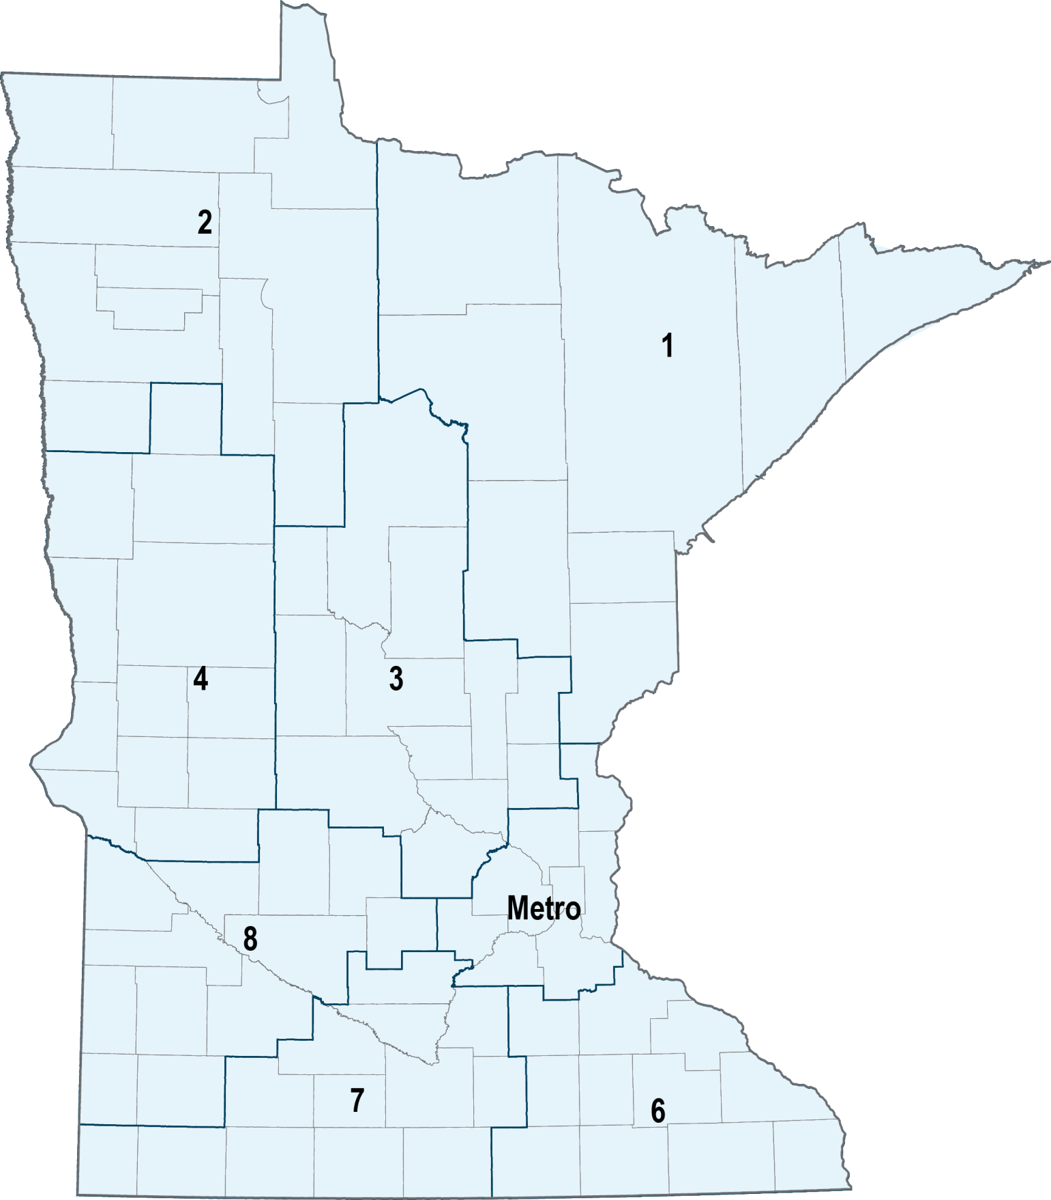

Area Transportation Partnership Contact Information
ATP | Counties served | Address & phone | Website
1 | Aitkin, Carlton, Cook, Itasca, Koochiching, Lake, Pine, St. Louis | 221 West 1st St  Duluth, MN 55802  218-722-5545 | www.nemnatp.org
2 | Beltrami, Clearwater, Hubbard, Kittson, Lake of the Woods, Marshall, Norman, Pennington, Polk, Red Lake, Roseau | MnDOT District 2  3920 Highway 2 West  Bemidji, MN 56601  218-755-6500 | www.dot.state.mn.us/d2/atp
3 | Benton, Cass, Crow Wing, Isanti, Kanabec, Mille Lacs, Morrison, Sherburne, Stearns, Todd, Wadena, Wright | MnDOT District 3  7694 Industrial Park Road  Baxter, MN 56425  218-828-5700 | www.dot.state.mn.us/d3/atp
4 | Becker, Big Stone, Clay, Douglas, Grant, Mahnomen, Otter Tail, Pope, Stevens, Swift, Traverse, Wilkin | MnDOT District 4  1000 Highway 10 West  Detroit Lakes, MN 56501  218-846-3600 | www.dot.state.mn.us/d4/atp
Metro | Anoka, Carver, Chisago, Dakota, Hennepin, Ramsey, Scott, Washington | MnDOT Metro District  1500 West Co Rd B-2  Roseville, MN 55113  651-234-7500 | www.dot.state.mn.us/metro
6 | Dodge, Fillmore, Freeborn, Goodhue, Houston, Mower, Olmsted, Rice, Steele, Wabasha, Winona | MnDOT District 6  2900 48th Street NW  Rochester, MN 55901  507-286-7500 | www.dot.state.mn.us/d6/atp
7 | Blue Earth, Brown, Cottonwood, Faribault, Jackson, LeSueur, Martin, Nicollet, Nobles, Rock, Sibley, Waseca, Watonwan | MnDOT District 7  2151 Bassett Drive  Mankato, MN 56001  507-304-6100 | www.dot.state.mn.us/d7/atp
8 | Chippewa, Kandiyohi, Lac qui Parle, Lincoln, Lyon, McLeod, Meeker, Murray, Pipestone, Redwood, Renville, Yellow Medicine | MnDOT District 8  2505 Transportation Road  Willmar, MN 56201  320-231-5195 | www.dot.state.mn.us/d8/atp
Note: Chisago County submits a Greater Minnesota TA application because it is not part of the seven-county Twin Cities metropolitan area, even though it is part of the Metro ATP. Chisago county TA applications are reviewed and scored by the East Central Regional Development Commission before they are forwarded to the Metro ATP integration committee.

Other Key Contacts

Safe Routes to School, Scenic Byway & Recreational Trails Program Coordinator Contact Information
Name | Role | Address & Phone | Email
Dave Cowan | MnDOT Safe Routes to School Non-Infrastructure Coordinator | 395 John Ireland Blvd  MS 315  St. Paul, MN 55155  651-366-4189 | Dave.Cowan@state.mn.us
Rashmi Brewer | MnDOT Safe Routes to School Engineering Coordinator | 395 John Ireland Blvd  MS 500  St. Paul, MN 55155  651-366-3827 | Rashmi.brewer@state.mn.us
Holly Slagle | MnDOT Scenic Byway Coordinator | 395 John Ireland Blvd  MS 620  St. Paul, MN 55155  651-366-3623 | Holly.Slagle@state.mn.us
Dan Golner | MnDNR Recreational Trails Coordinator | 500 Lafayette Road  Box 39  Saint Paul, MN 55155  651-259-5599 | Daniel.Golner@state.mn.us

Statewide Transportation Alternatives Contact Information
Name | Role | Address & Phone | Email
Karen Scheffing | MnDOT Transportation Alternatives Coordinator | 395 John Ireland Blvd  MS 440  St. Paul, MN 55155  651-366-3736 | karen.scheffing@state.mn.us

